Assignment-7

Manasa Vathumilli -700745467

**GitHub link**: https://github.com/Manasav17/Assignment-7

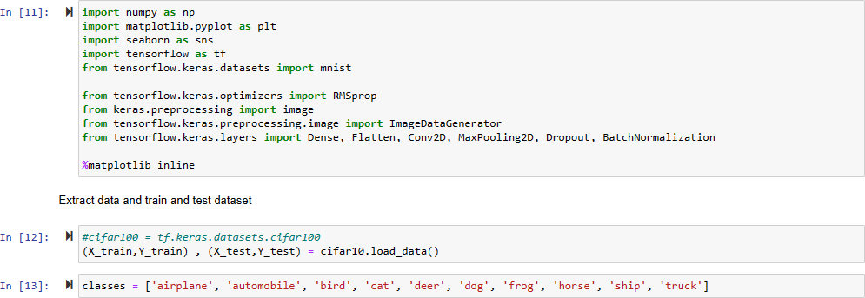

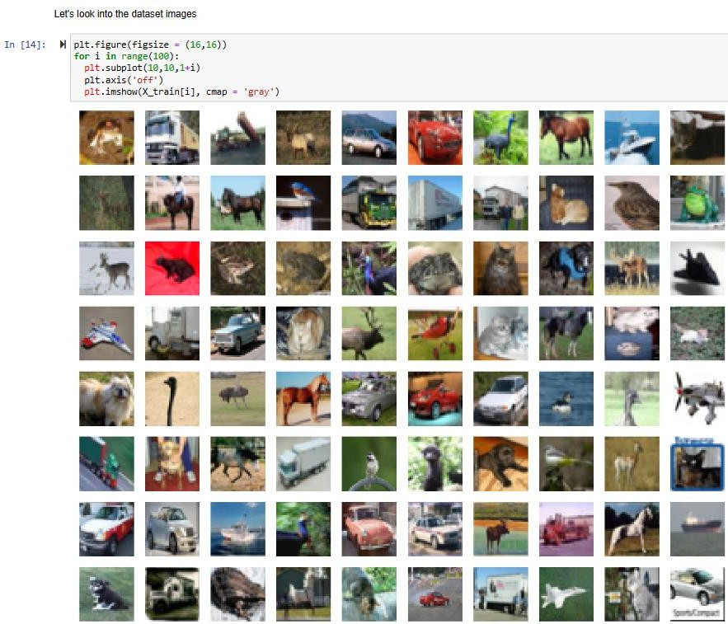

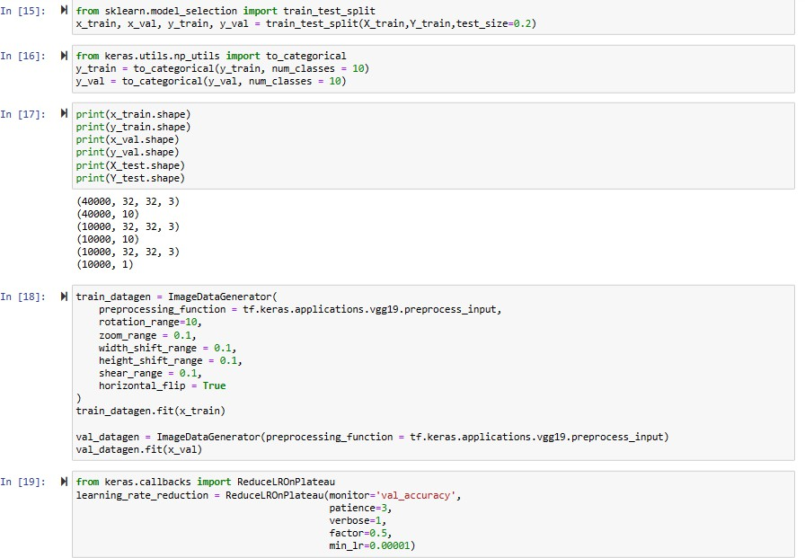

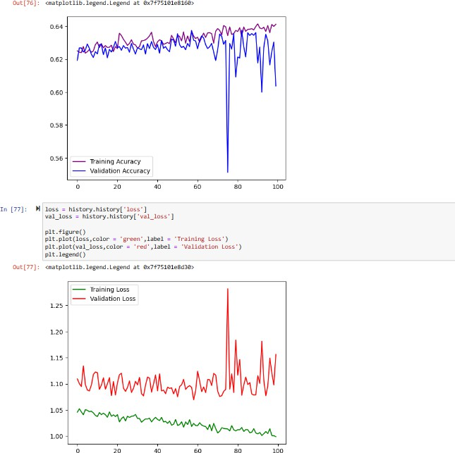

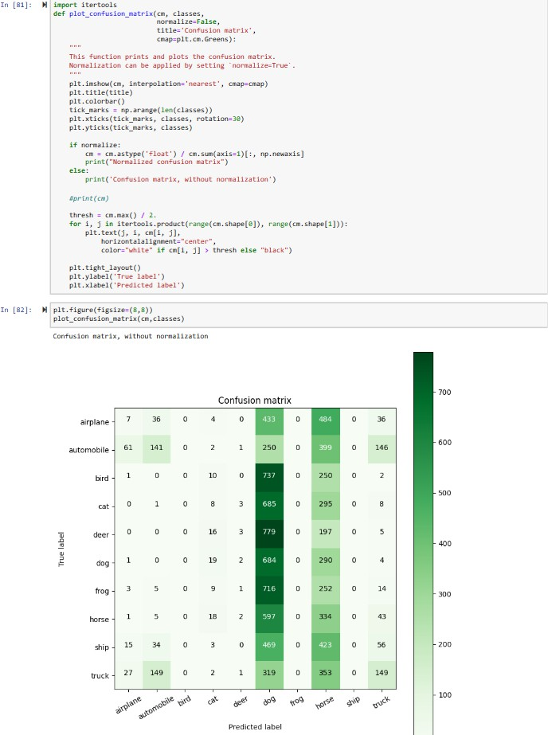

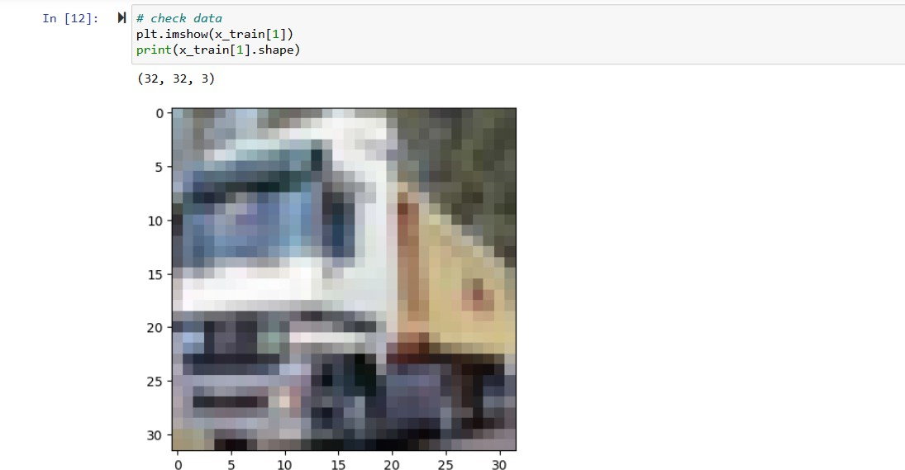

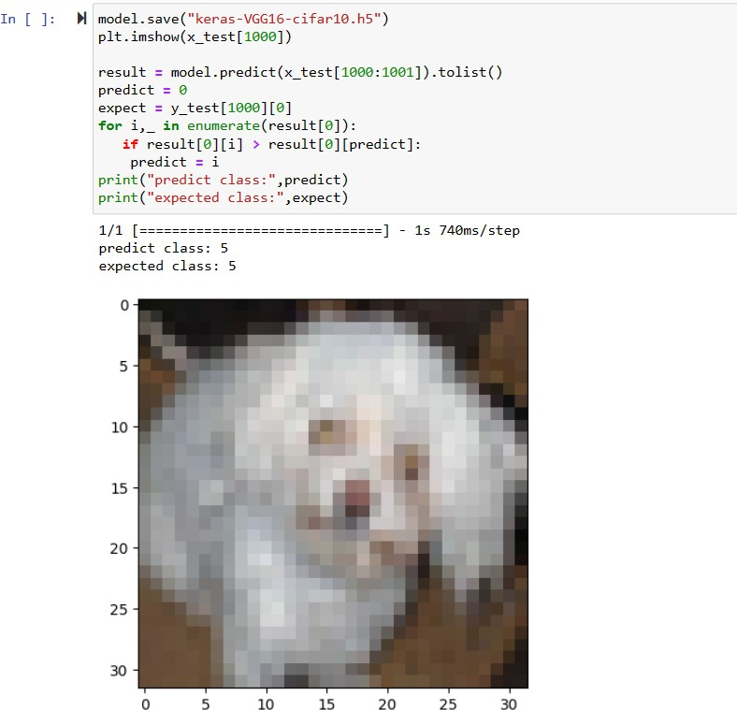

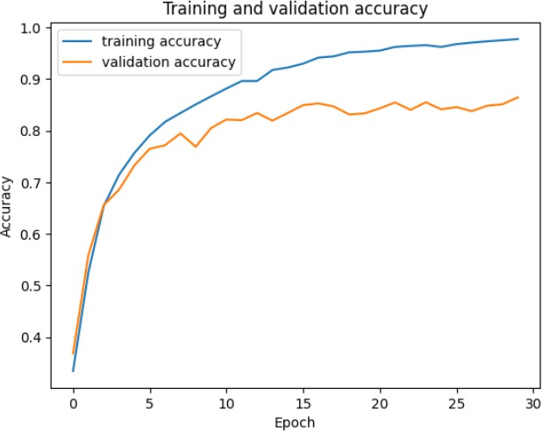

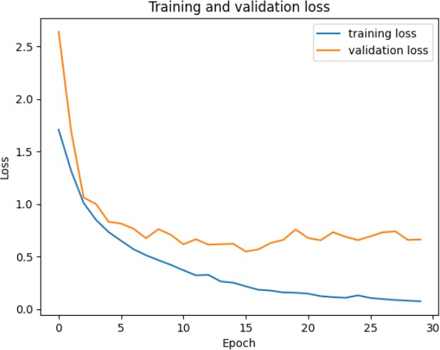

**Description**: In this assignment I have developed this program where the Convolutional input layer, 32 feature maps with a size of 3×3 and a rectifier activation function and the Dropout layer at 20%

Convolutional layer, 32 feature maps with a size of 3×3 and a rectifier activation function where the Max Pool layer with size 2×2

Convolutional layer, 64 feature maps with a size of 3×3 and a rectifier activation function and the Dropout layer at 20%

Convolutional layer, 64 feature maps with a size of 3×3 and a rectifier activation function and the Max Pool layer with size 2×2

Convolutional layer, 128 feature maps with a size of 3×3 and a rectifier activation function and the Dropout layer at 20%.

Convolutional layer,128 feature maps with a size of 3×3 and a rectifier activation function and the Max Pool layer with size 2×2

Flatten layer Dropout layer at 20%. Fully connected layer with 1024 units and a rectifier activation function and the Dropout layer at 20%. Fully connected layer with 512 units and a rectifier activation function and the Dropout layer at 20%. Fully connected output layer with 10 units and a Softmax activation function.The performance has changed.

Predicted the first 4 images of the test data using the above model. Then, compared with the actual label for those 4 images to check whether or not the model has predicted was not correct. Visualized the Loss and Accuracy using the history object.

Video Link: https://drive.google.com/file/d/1131JX93dY4yoIq3kd2XABizjrB1Zyi0g/view?usp=sharing